**EXP NO: 15 DATE:15-03-24**

**Aim:** To Create a Cloning of a VM and Test it by loading the Previous Version/Cloned VM.

**Implementation:**

1.install and setup VM ware software and create a new virtual machine

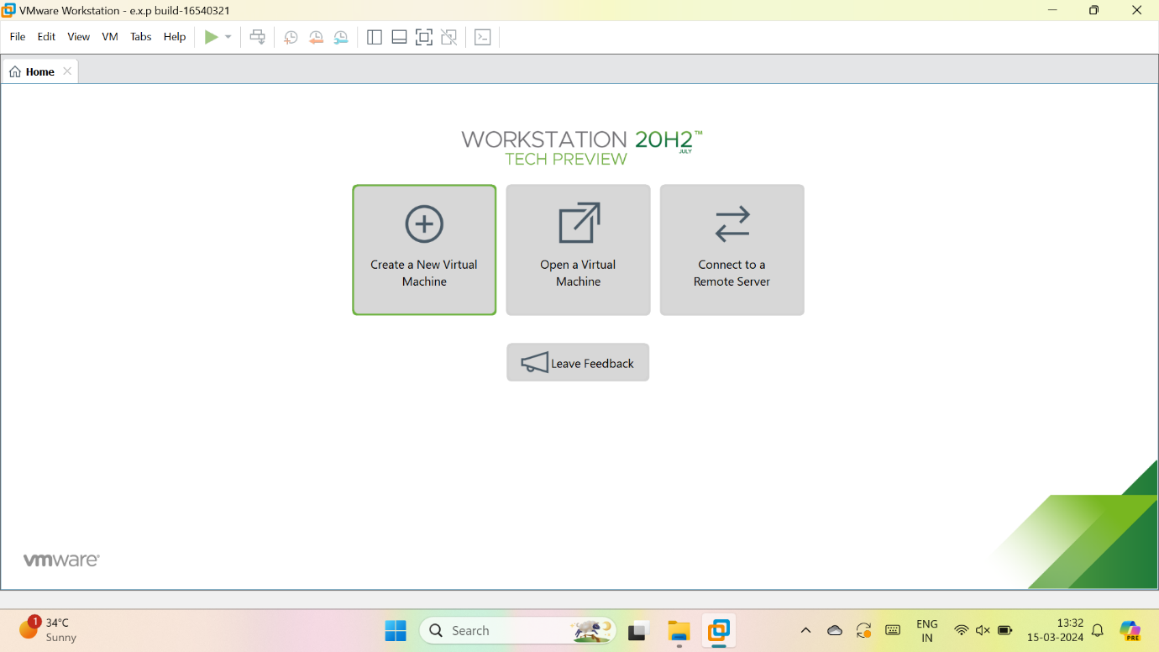

2.select typical

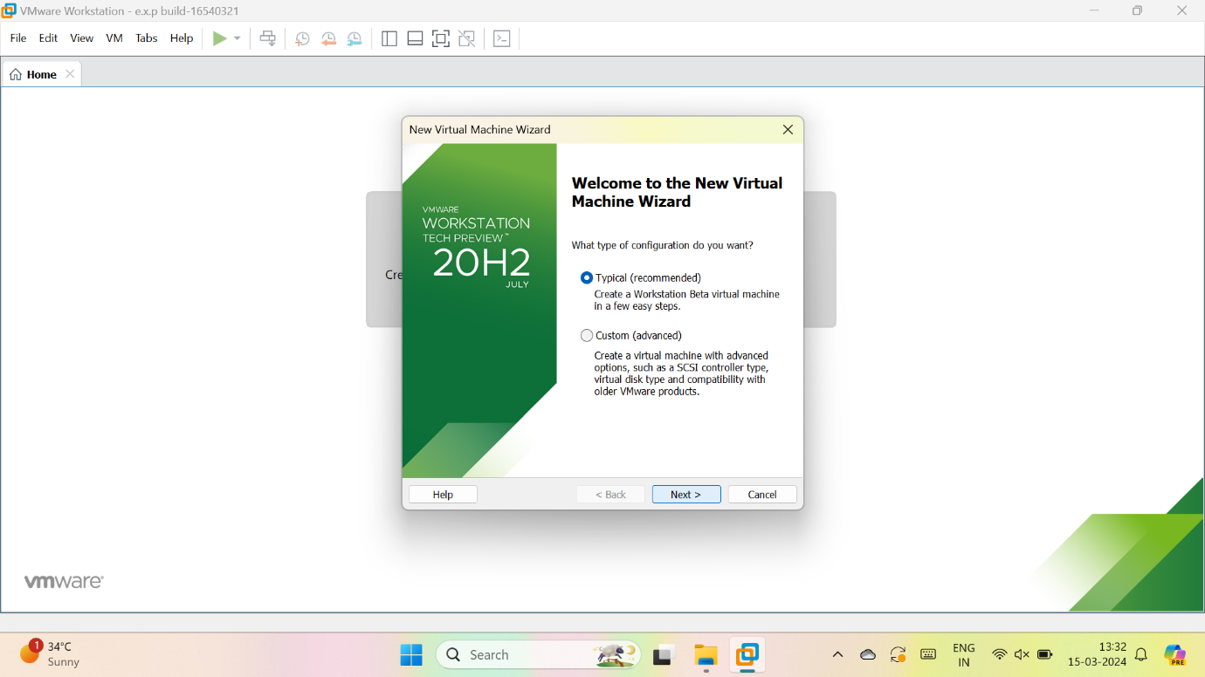

3.we have to select, I will install the OS later

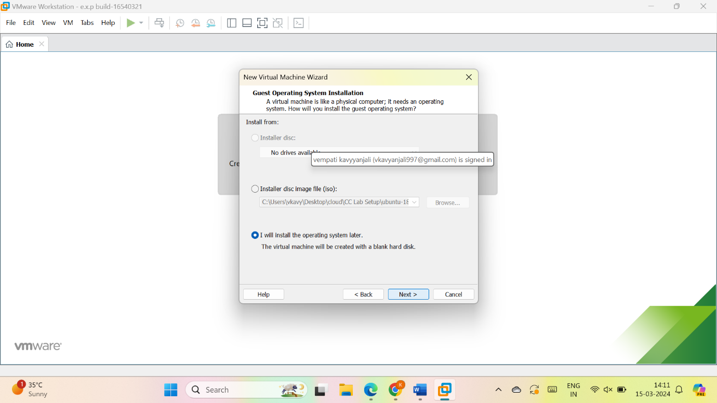

4.give name for VM

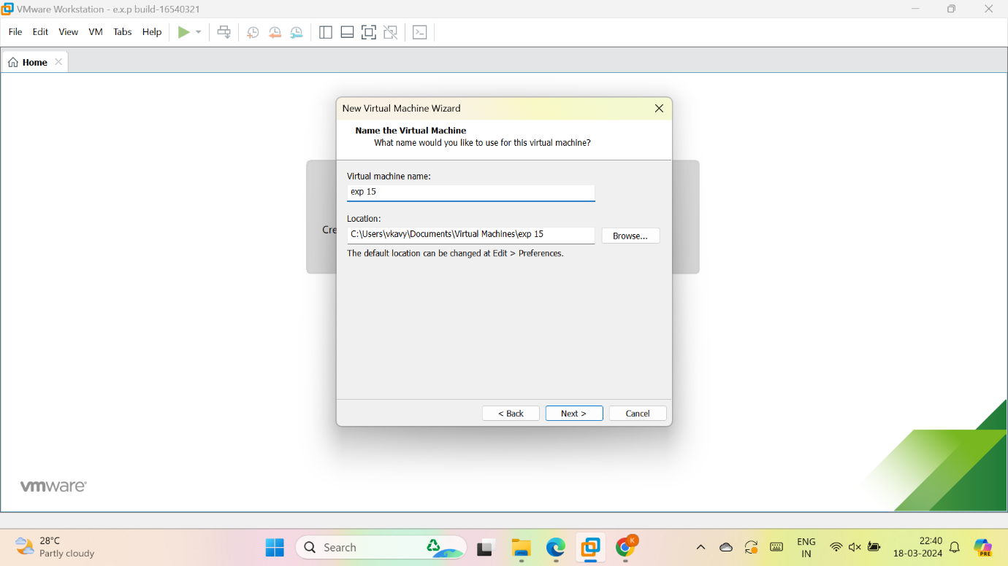

5.give the maximum size of disk as 20GB and select, store virtual disk as a single file and give next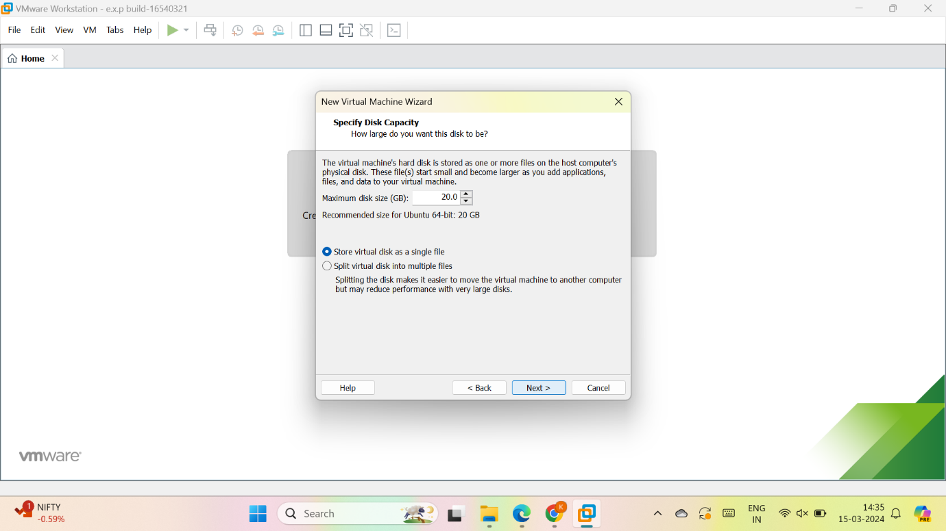

6.check the description

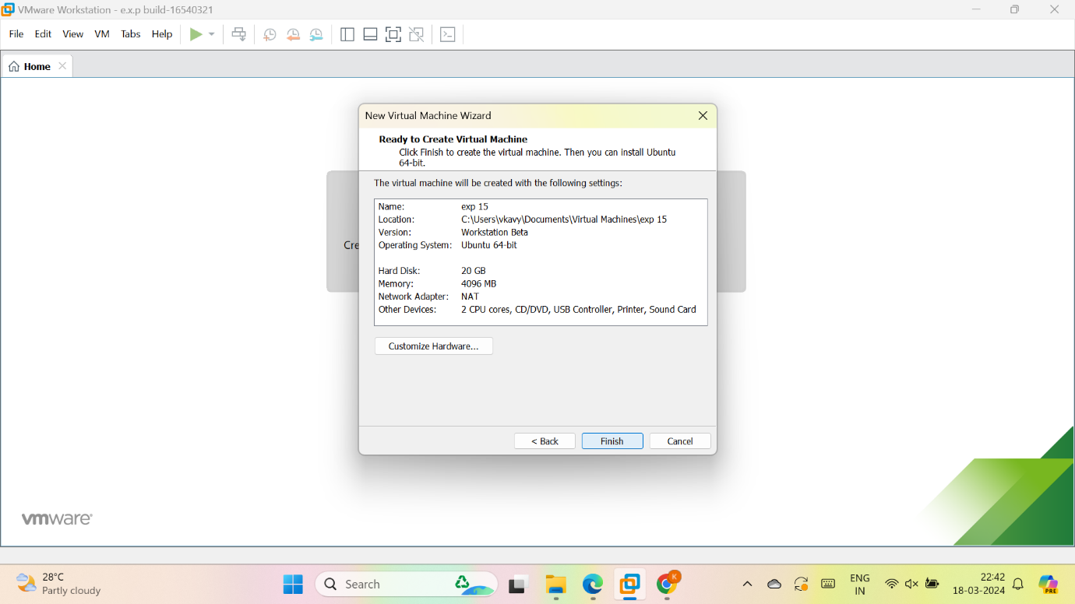

7.vm is created

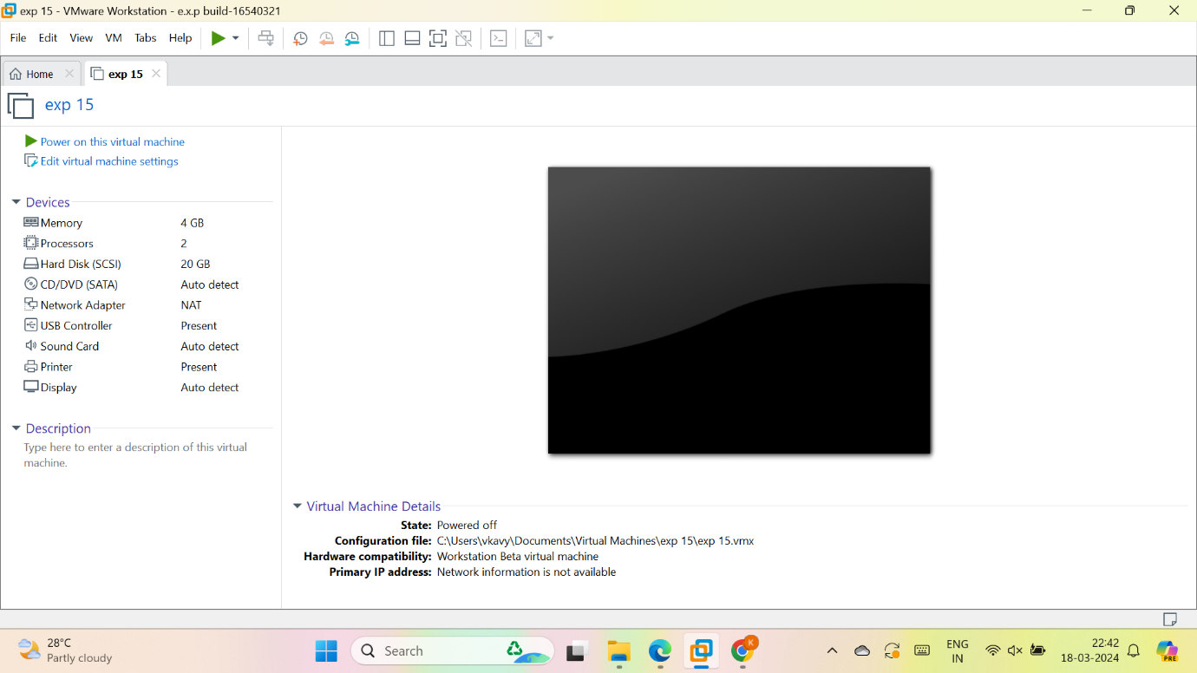

8. to create clone:

go to VM in task bar > Select manage > select clone

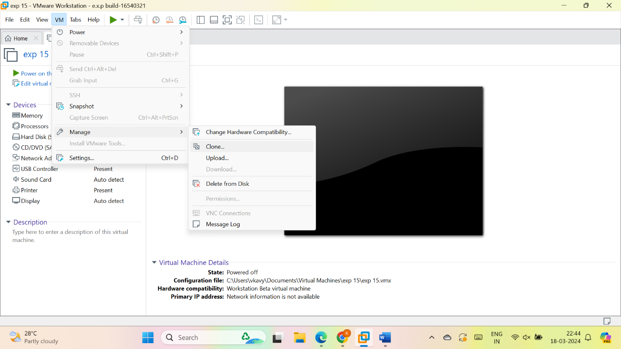

Select next

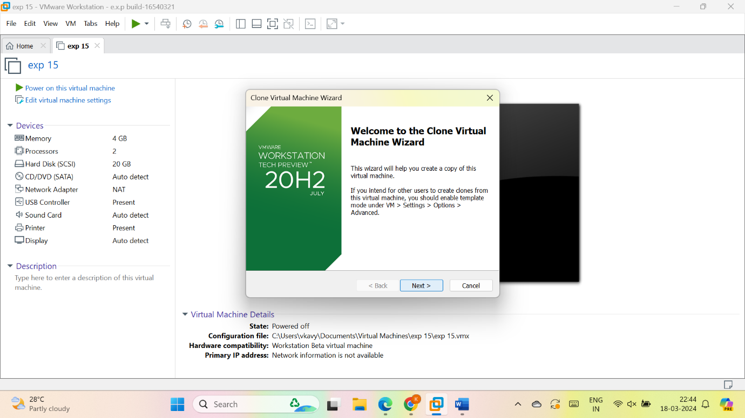

Select current state

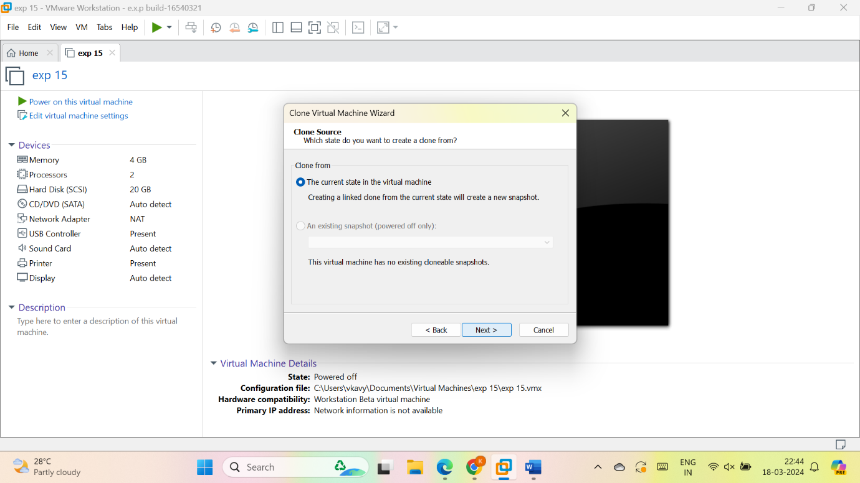

Create a full done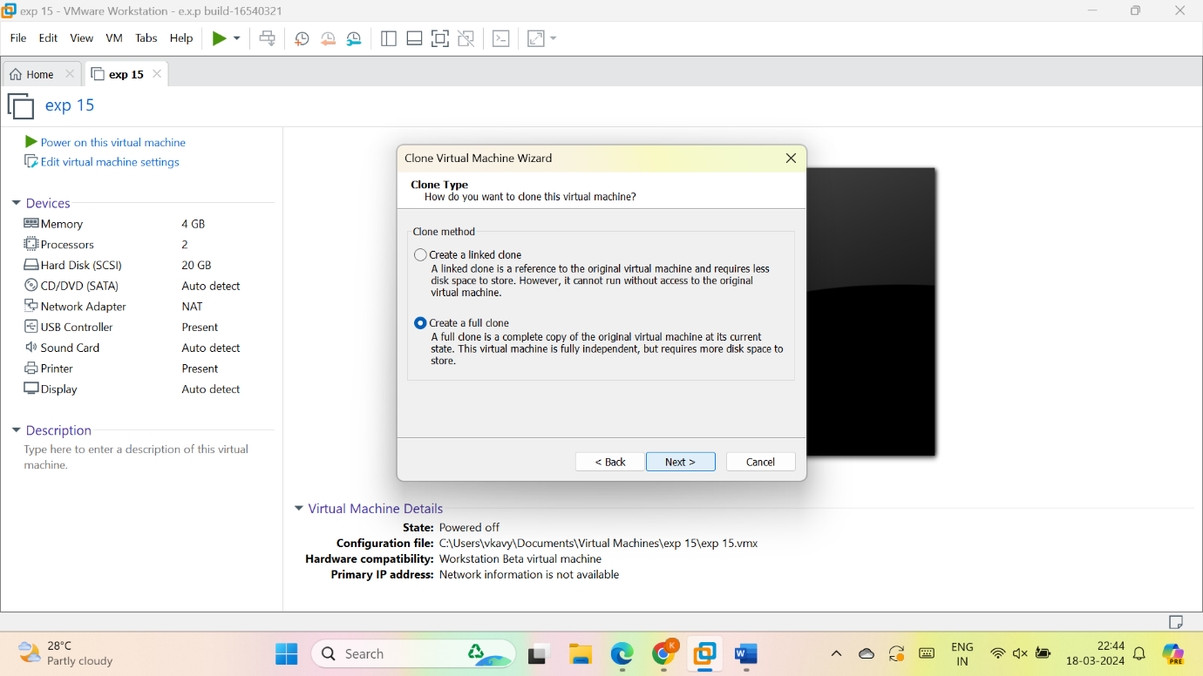

Give name for cloud VM

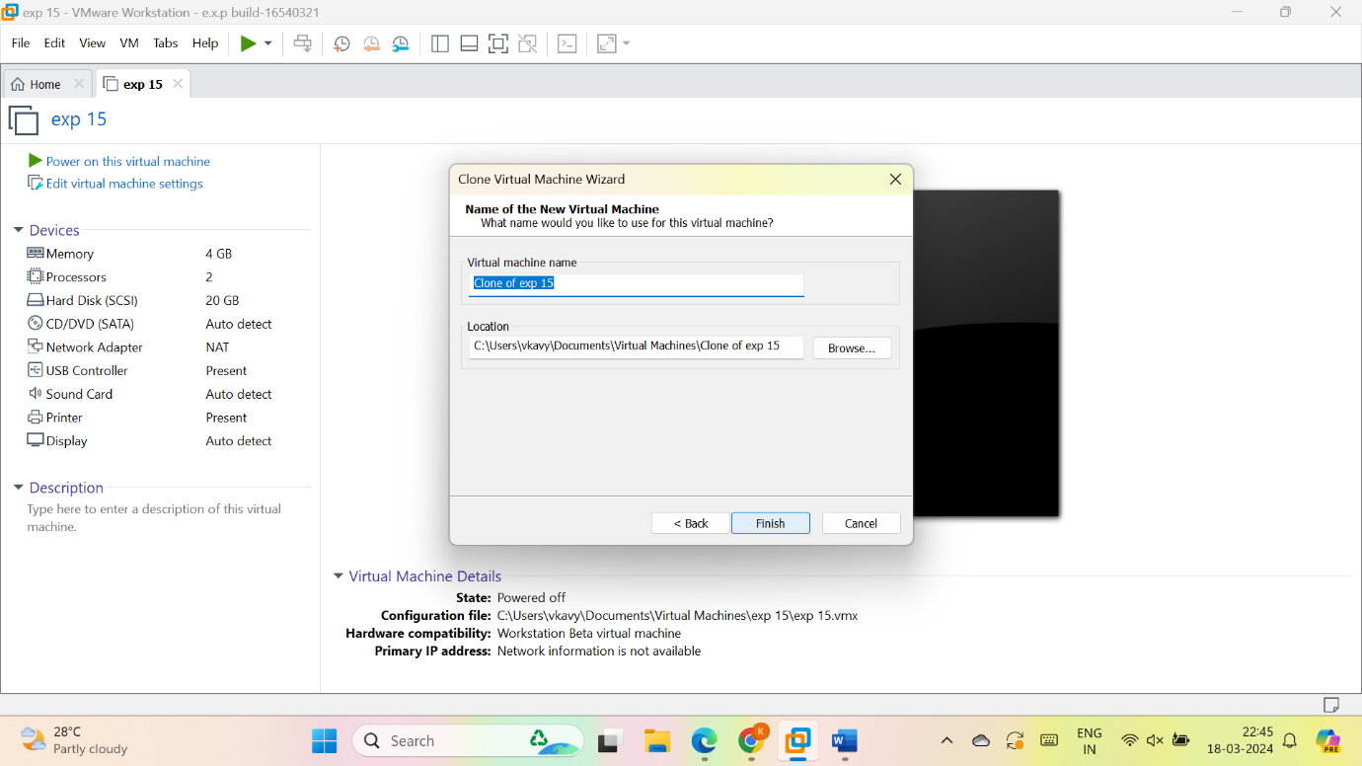

close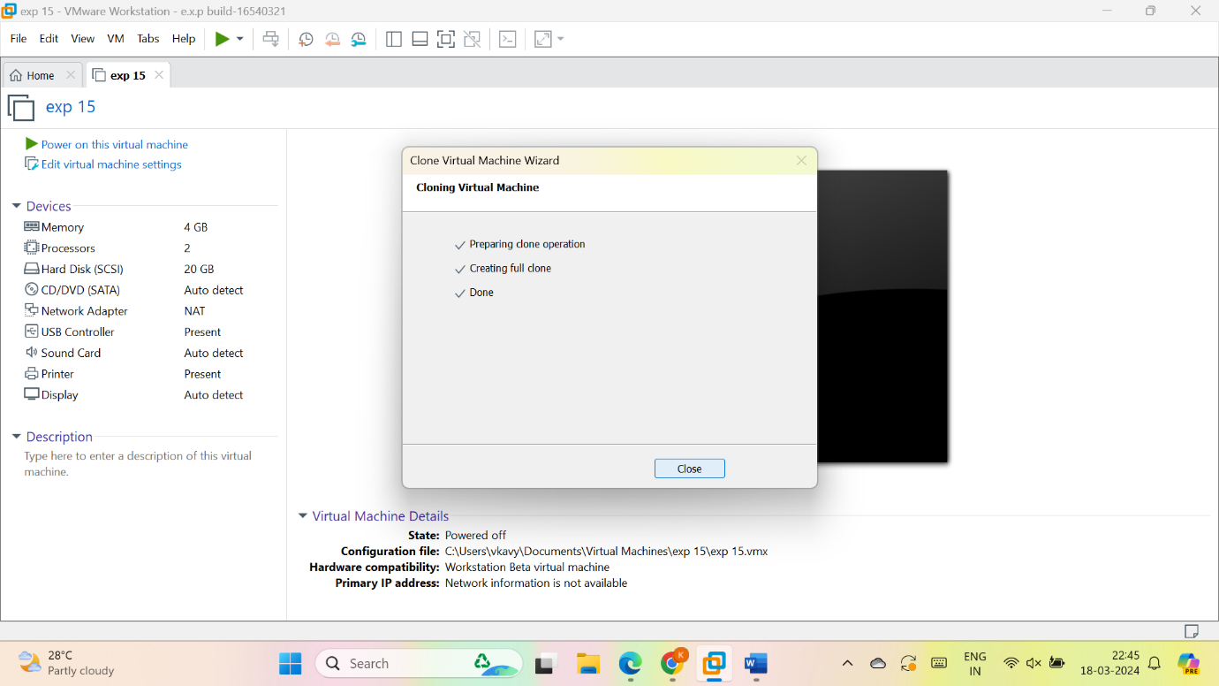

the cloud VM is created

